Restore Script Instructions

1. Run the script **from the user’s profile.**
2. Enter the parent folder of your **Backups** folder here. In this example, the Backups folder sits in the C:\temp folder.  
   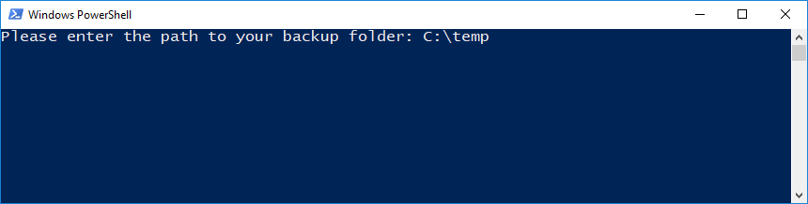
3. The script will now run through and restore all the user’s data.  
   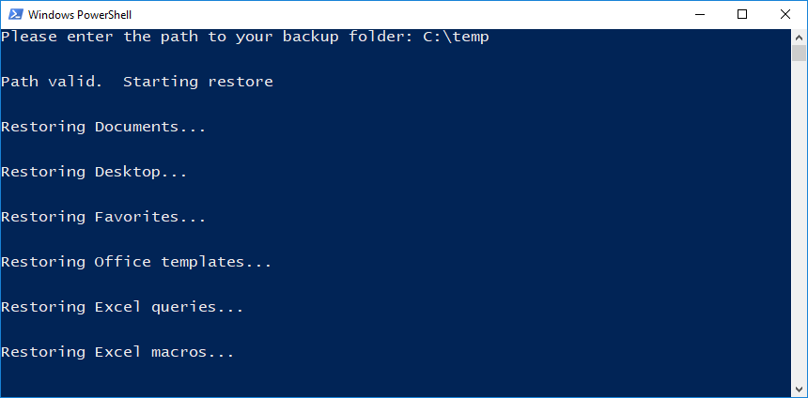
4. Currently there are a few issues with the script that are being worked on:

* The Outlook profile is not automatically created when Office 2016 is present. You will need to manually click through the profile creation.
* ODBC connections may not be remapped
* The user’s taskbar will be restored completely on the next login
* They will only be placed into the Remote Desktop User’s group if they have admin rights.